**Student Grievance Redressal Committee**

As per the directives of APJ Abdul Kalam Technological University (APJAKTU), engineering colleges affiliated with the university are required to establish a **Student Grievance Redressal Committee (SGRC)**. This committee serves as a structured mechanism to address and resolve student grievances related to academic, administrative, and other matters within the institution.​

**Objectives**

The primary objectives of the SGRC are to:

* Provide a fair, impartial, and consistent mechanism for redressal of student grievances.
* Promote a harmonious educational environment by addressing issues promptly and effectively.
* Ensure confidentiality and sensitivity in handling grievances.
* Uphold the dignity of the institution by fostering respectful relationships among students, faculty, and staff.​

**Composition**

The present Student Grievance Redressal Committee is given below:

|  |  |  |  |
| --- | --- | --- | --- |
| **Sl. No.** | **Name** | **Designation** | **Email** |
| 1 | Dr. K Krishnakumar, Principal | Chairperson | principal@sbce.ac.in |
| 2 | Dr. Saji Varghese, Vice Principal | Co-Chairperson | saji57@yahoo.com |
| 3 | **Dr. Sujith Kumar, PG Dean** | **Convener** | cs.sujith@sbcemail.in |
| 4 | Mr. Harikrishnan G, AP, ME | Member | harikrishnangs24@gmail.com |
| 5 | Ms. Priya R, AP, BS | Member | priyarochu@gmail.com |
| 6 | Ms. Chinchu Elezebeth, AP, BT&BCE | Member | chinchuelezebeth@gmail.com |
| 7 | Ms. Sreelekshmi S., AP, CE | Member | ce.aswathys@sbcemail.in |
| 8 | Ms. Reshmi S, AP, CSE | Member | cs.reshmis@sbcemail.in |
| 9 | Ms. Anju Viswam, AP, AI&ML | Member | cs.hema@sbcemail.in |
| 10 | Mr. Hari S, AP, ECE | Member | hari.sivankylm@gmail.com |
| 11 | Mr. Ananthu Vijayakumar, AP, EEE | Member | ee.ananthuv@sbcemail.in |
| 12 | Ms. Sholly Joseph, PRO | Member | shollyjoseph12@gmail.com |
| 13 | Special invitee | Student Member | abhinandh890@gmail.com |

* **Grievance Redressal Mechanism**

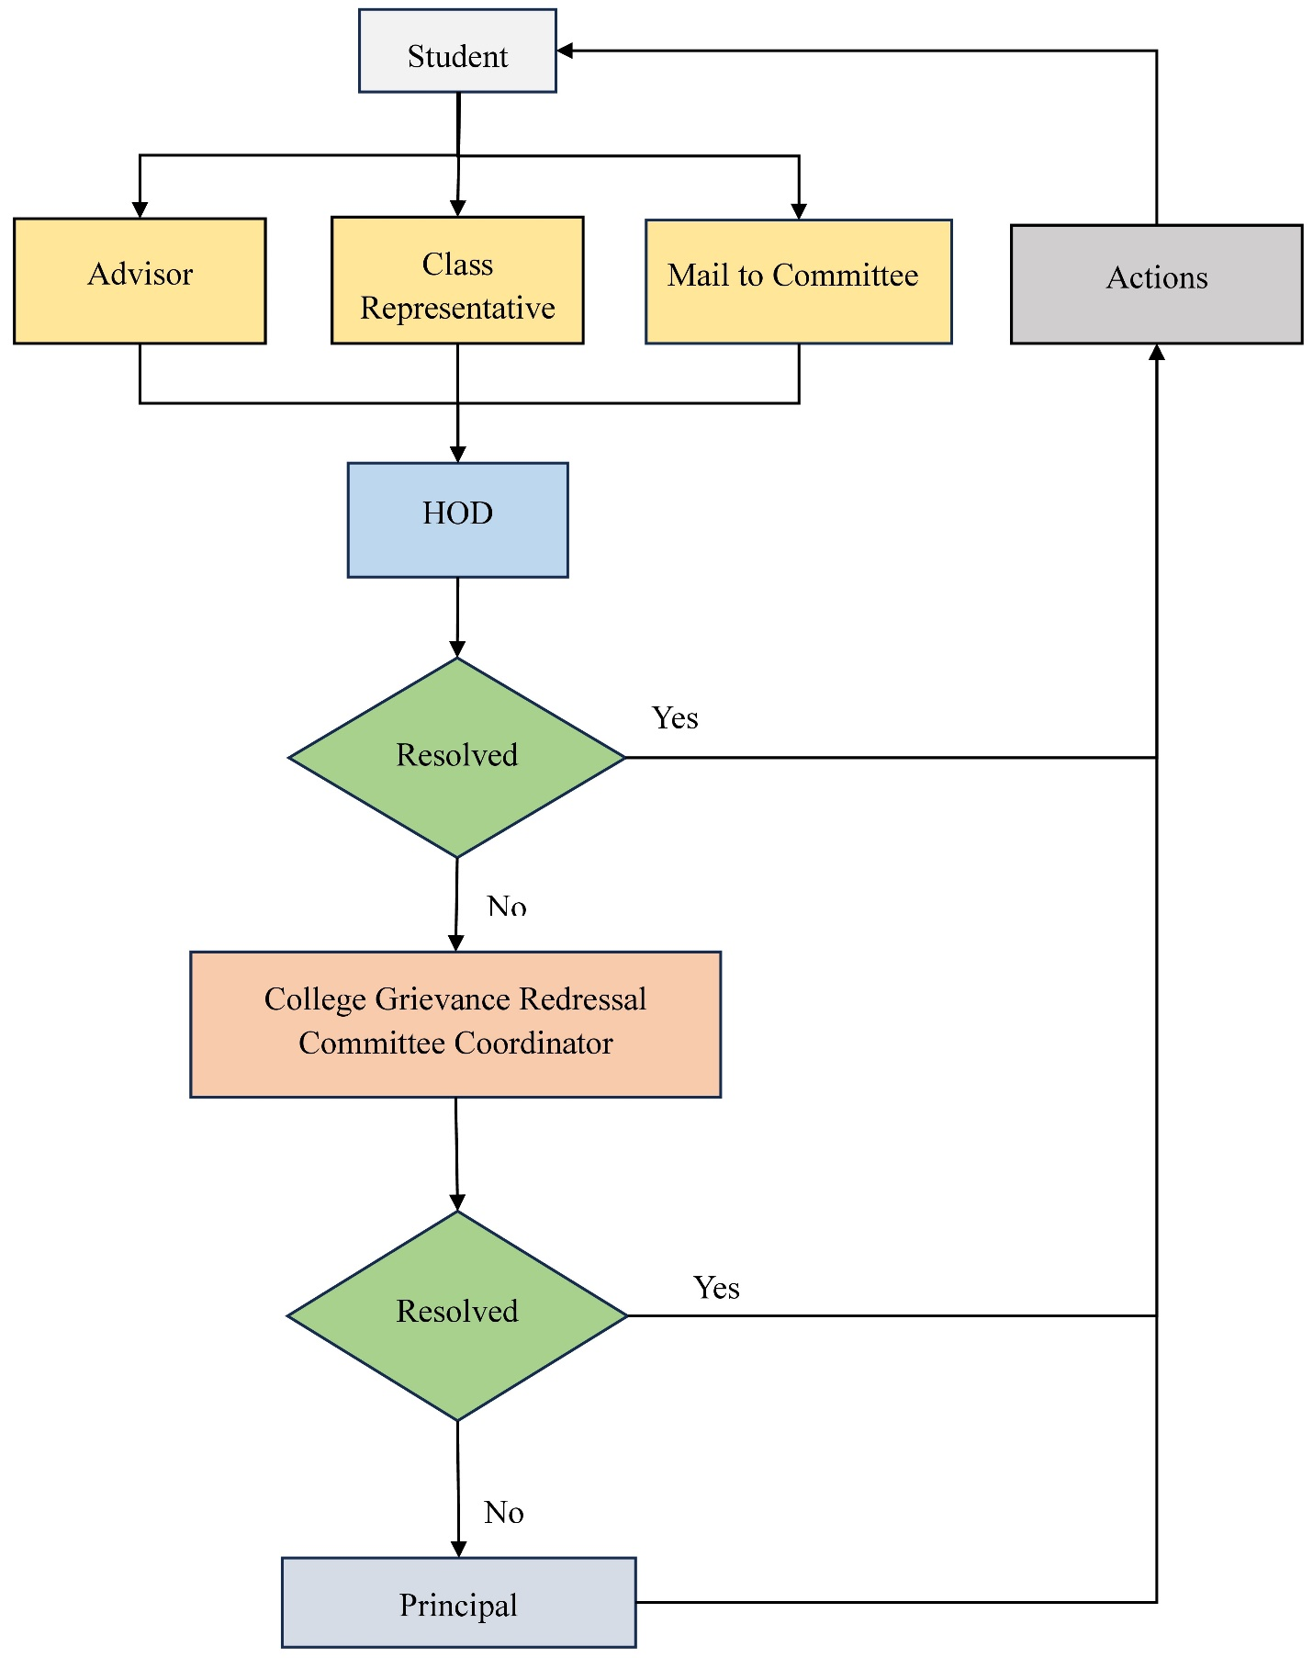

**Functions**

The SGRC is entrusted with:

* Receiving and documenting grievances from students.
* Conducting thorough investigations into the complaints.
* Facilitating discussions between aggrieved parties to reach amicable solutions.
* Recommending appropriate actions or remedies based on findings.
* Maintaining records of grievances and resolutions for future reference.​